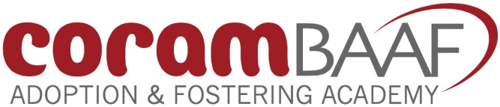
CoramBAAF Adoption & Fostering Academy
41 Brunswick Square, London WC1N 1AZ
Phone: 020 7520 0300 www.corambaaf.org.uk
Company Number 9697712

CoramBAAF Agency Members’ Annual Reception

Friday 14 September 2018

Programme
10.15am | Registration and refreshments
10.45am | Welcome and opening address by Chair  Paul Curran, Chair of CoramBAAF Board of Directors
10.55am | Fostering Better Outcomes  Emma Balmforth, Policy Adviser, Children in Care and Permanence, Department for Education (DfE)
11.30am | Setting up an RAA – Lessons from practice  Sarah Johal, Head of One Adoption West Yorkshire
12.05pm | Discussion
12.20pm | LUNCH
1.00pm  1.10pm | Informing and influencing CoramBAAF’s work  John Simmonds, Director, Policy Research and Development  CoramBAAF’s UK Social Work Practice and Research Advisory Committees  Carole Sykes, Operations Manager, Adoption and Permanence Team, East Sussex County Council  Derek Kirton, Reader in Social Policy and Social Work, University of Kent
1.50pm | CoramBAAF’s Special Guardianship Special Interest Group and the Black Workers’ Practice Forum (North)  Elaine Dibben, Adoption Development Consultant, CoramBAAF  Bernadette Caines, The Concurrency Planning Service, Yorkshire and Humber  and  Shanti Davis, Support Worker, Fostering Services, Sheffield City Council
2.30pm | A little bit more – what else can CoramBAAF do to support you?  Workshop session
3.05pm | Key messages from group discussions
3.15pm | Close

